**Module 18: Accessing API ESSENTIAL**

* Introduction

**API (Application Programming Interface):**

* + A set of rules that allows one software application to interact with another.
  + APIs enable communication between different services without needing to understand their internal code.
  + Example: Using Google Maps API in an app to show location without building maps from scratch.

**Why use APIs?**

* + Reuse existing services (e.g., weather data, social media features).
  + Save development time.
  + Access real-time data.

**Types of APIs:**

* + **REST API** – Based on HTTP methods (GET, POST, PUT, DELETE).
  + **SOAP API** – Uses XML-based protocol (less common now).
  + **GraphQL** – Flexible query-based API.
* OpenWeather — EXAMPLE WITH definition

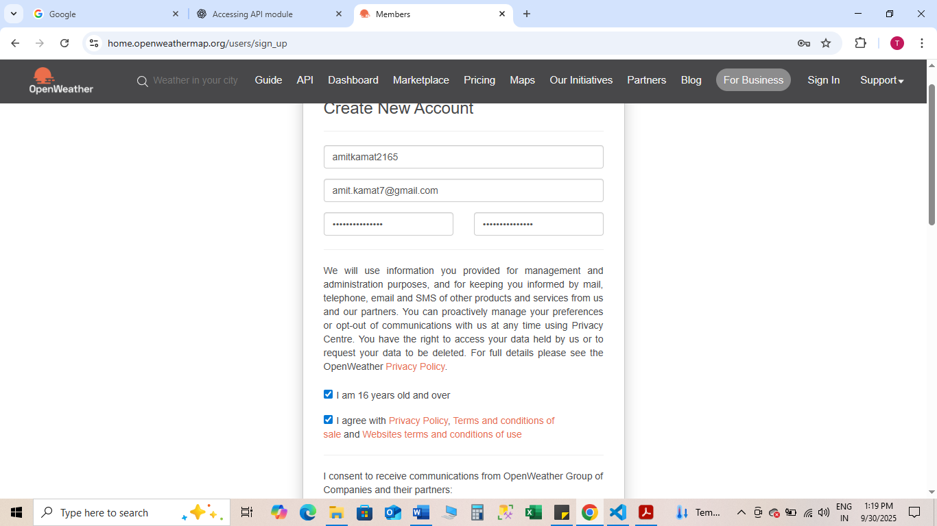

Pass Word-A*********5

**What is OpenWeather? — Definition**

OpenWeather (OpenWeatherMap) is a web service that provides weather data — current weather, forecasts, and historical data — via HTTP APIs. Developers use it to fetch temperature, humidity, wind, weather descriptions, etc.

**Authentication**

OpenWeather uses an **API key** (a secret string) that you include in requests. Keep it private and do not push it to public repositories.

Example: Python requests — current weather

import requests

API_KEY = "e8299340445062614d77e12c71ff88a4"

url = "https://api.openweathermap.org/data/2.5/weather"

params = {

    "q": "Delhi",

    "appid": API_KEY,   # use your real key

    "units": "metric"

}

response = requests.get(url, params=params)

data = response.json()

print("🔍 Full API Response:", data)  # Debug line

# Only print weather if response is valid

if response.status_code == 200 and "main" in data:

    print("City:", data["name"])

    print("Temperature:", data["main"]["temp"], "°C")

    print("Weather:", data["weather"][0]["description"])

else:

    print("❌ Error:", data.get("message", "Unknown error"))

Real Life project on current weather using API

import requests

from datetime import datetime

API_KEY = "e8299340445062614d77e12c71ff88a4"

BASE_URL = "https://api.openweathermap.org/data/2.5/weather"

def get_weather(city=None, lat=None, lon=None):

    params = {

        "appid": API_KEY,

        "units": "metric"

    }

    # If city name is given, use it

    if city:

        params["q"] = city

    # Otherwise, use latitude/longitude

    elif lat is not None and lon is not None:

        params["lat"] = lat

        params["lon"] = lon

    else:

        return {"error": "Please provide either city name or latitude & longitude"}

    response = requests.get(BASE_URL, params=params)

    data = response.json()

    if response.status_code == 200 and "main" in data:

        # Convert UNIX timestamps to human-readable format

        sunrise = datetime.fromtimestamp(data['sys']['sunrise']).strftime("%I:%M %p")

        sunset = datetime.fromtimestamp(data['sys']['sunset']).strftime("%I:%M %p")

        weather_info = {

            "City": data.get("name", "Unknown"),

            "Temperature": f"{data['main']['temp']} °C",

            "Feels Like": f"{data['main']['feels_like']} °C",

            "Weather": data['weather'][0]['description'],

            "Humidity": f"{data['main']['humidity']}%",

            "Wind Speed": f"{data['wind']['speed']} m/s",

            "Sunrise": sunrise,

            "Sunset": sunset

        }

        return weather_info

    else:

        return {"error": data.get("message", "Unknown error")}

# Example usage

if __name__ == "__main__":

    # By city name

    print("🔹 Darbhanga Weather:", get_weather(city="Darbhanga"))

    # By latitude/longitude

    print("🔹 Weather by coordinates:", get_weather(lat=26.1542, lon=85.8918))

Real Life project to develop a weather APP using API and GUI

import requests

from datetime import datetime

import tkinter as tk

from tkinter import messagebox

API_KEY = "e8299340445062614d77e12c71ff88a4"

BASE_URL = "https://api.openweathermap.org/data/2.5/weather"

def get_weather(city):

    params = {

        "appid": API_KEY,

        "q": city,

        "units": "metric"

    }

    response = requests.get(BASE_URL, params=params)

    data = response.json()

    if response.status_code == 200 and "main" in data:

        sunrise = datetime.fromtimestamp(data['sys']['sunrise']).strftime("%I:%M %p")

        sunset = datetime.fromtimestamp(data['sys']['sunset']).strftime("%I:%M %p")

        report = (

            f" City: {data['name']}\n"

            f" Temperature: {data['main']['temp']} °C\n"

            f"🤔 Feels Like: {data['main']['feels_like']} °C\n"

            f"⛅ Weather: {data['weather'][0]['description'].title()}\n"

            f" Humidity: {data['main']['humidity']}%\n"

            f"💨 Wind Speed: {data['wind']['speed']} m/s\n"

            f" Sunrise: {sunrise}\n"

            f" Sunset: {sunset}"

        )

        return report

    else:

        return f"❌ Error: {data.get('message', 'Unknown error')}"

# Function for button click

def show_weather():

    city = city_entry.get()

    if city.strip() == "":

        messagebox.showwarning("Input Error", "Please enter a city name")

        return

    weather_report = get_weather(city)

    result_label.config(text=weather_report)

# GUI Setup

root = tk.Tk()

root.title("🌦 Weather App")

root.geometry("400x350")

root.config(bg="#f0f8ff")

title_label = tk.Label(root, text="Weather App", font=("Arial", 16, "bold"), bg="#f0f8ff", fg="blue")

title_label.pack(pady=10)

city_entry = tk.Entry(root, font=("Arial", 14), justify="center")

city_entry.pack(pady=5)

get_button = tk.Button(root, text="Get Weather", font=("Arial", 12, "bold"), bg="lightblue", command=show_weather)

get_button.pack(pady=10)

result_label = tk.Label(root, text="", font=("Arial", 12), justify="left", bg="#f0f8ff", fg="black")

result_label.pack(pady=10)

root.mainloop()

**Real life Example of News App using API and GUI**

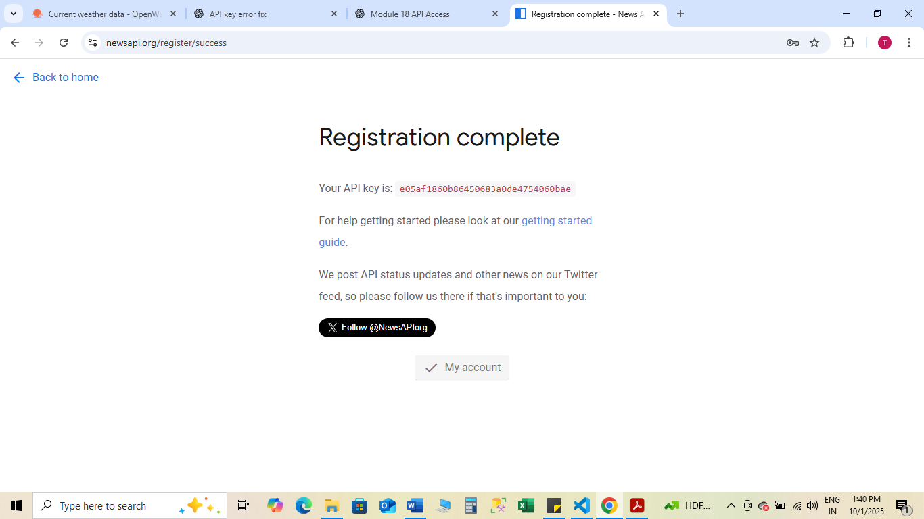

ID-S****_96

Pass Word-Amit******_****5

import requests

import tkinter as tk

from tkinter import ttk, messagebox

API_KEY = "e05af1860b86450683a0de4754060bae"  # 🔑 Replace with your NewsAPI key

BASE_URL = "https://newsapi.org/v2/top-headlines"

def get_news(category="general"):

    params = {

        "apiKey": API_KEY,

        "country": "us",      # 'in' for India, 'us' for USA, etc.

        "category": category

    }

    response = requests.get(BASE_URL, params=params)

    data = response.json()

    if data.get("status") == "ok":

        articles = data.get("articles", [])

        headlines = [f"📰 {a['title']}" for a in articles if a["title"]]

        return headlines[:10] if headlines else ["No news found."]

    else:

        return [f"❌ Error: {data.get('message', 'Unknown error')}"]

def show_news():

    category = category_var.get()

    headlines = get_news(category)

    news_list.delete(0, tk.END)  # clear old news

    for h in headlines:

        news_list.insert(tk.END, h)

# GUI Setup

root = tk.Tk()

root.title("📰 News App")

root.geometry("500x400")

root.config(bg="#f8f9fa")

title_label = tk.Label(root, text="Latest News Headlines", font=("Arial", 16, "bold"), bg="#f8f9fa", fg="blue")

title_label.pack(pady=10)

# Dropdown for category

category_var = tk.StringVar(value="general")

categories = ["general", "business", "sports", "technology", "entertainment", "health", "science"]

category_menu = ttk.Combobox(root, textvariable=category_var, values=categories, state="readonly", font=("Arial", 12))

category_menu.pack(pady=5)

get_button = tk.Button(root, text="Get News", font=("Arial", 12, "bold"), bg="lightblue", command=show_news)

get_button.pack(pady=10)

# Listbox to display news

news_list = tk.Listbox(root, font=("Arial", 12), width=60, height=12, bg="white", fg="black")

news_list.pack(pady=10)

root.mainloop()

Real Life project to develop a TIMES OF INDIA new APP using API and GUI

import requests

import tkinter as tk

from tkinter import ttk, messagebox

import webbrowser

API_KEY = "e05af1860b86450683a0de4754060bae"  # 🔑 Replace with your NewsAPI key

BASE_URL = "https://newsapi.org/v2/top-headlines"

def get_news(category="general", source=None):

    params = {

        "apiKey": API_KEY,

        "pageSize": 10  # fetch top 10 articles

    }

    if source:  # fetch from a specific source like TOI

        params["sources"] = source

    else:  # fetch by country & category

        params["country"] = "in"

        params["category"] = category

    response = requests.get(BASE_URL, params=params)

    data = response.json()

    if data.get("status") == "ok":

        articles = data.get("articles", [])

        # Each headline stores title + URL for clicking

        headlines = [{"title": a["title"], "url": a["url"]} for a in articles if a["title"]]

        return headlines if headlines else [{"title": "No news found.", "url": None}]

    else:

        return [{"title": f"❌ Error: {data.get('message', 'Unknown error')}", "url": None}]

def show_news():

    news_list.delete(0, tk.END)

    if source_var.get() == "Times of India":

        articles = get_news(source="the-times-of-india")

    else:

        category = category_var.get()

        articles = get_news(category=category)

    for article in articles:

        news_list.insert(tk.END, article["title"])

    # Store URLs for opening

    global current_articles

    current_articles = articles

def open_article(event):

    selection = news_list.curselection()

    if selection:

        index = selection[0]

        url = current_articles[index]["url"]

        if url:

            webbrowser.open(url)

# GUI Setup

root = tk.Tk()

root.title("📰 India News App")

root.geometry("600x450")

root.config(bg="#f8f9fa")

title_label = tk.Label(root, text="India News Headlines", font=("Arial", 16, "bold"), bg="#f8f9fa", fg="blue")

title_label.pack(pady=10)

# Source selection

source_var = tk.StringVar(value="India")

source_menu = ttk.Combobox(root, textvariable=source_var, values=["India", "Times of India"], state="readonly", font=("Arial", 12))

source_menu.pack(pady=5)

# Category dropdown

category_var = tk.StringVar(value="general")

categories = ["general", "business", "sports", "technology", "entertainment", "health", "science"]

category_menu = ttk.Combobox(root, textvariable=category_var, values=categories, state="readonly", font=("Arial", 12))

category_menu.pack(pady=5)

get_button = tk.Button(root, text="Get News", font=("Arial", 12, "bold"), bg="lightblue", command=show_news)

get_button.pack(pady=10)

# Listbox for headlines

news_list = tk.Listbox(root, font=("Arial", 12), width=80, height=15, bg="white", fg="black")

news_list.pack(pady=10)

news_list.bind("<Double-Button-1>", open_article)  # double-click to open article

current_articles = []  # store currently displayed articles

root.mainloop()